

**NIKE, INC.**



By: Joey Nader

**Business Description**

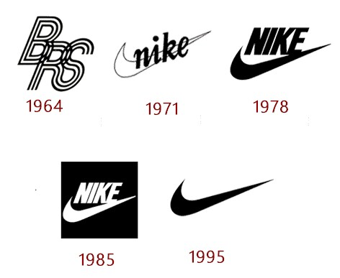

Nike is an American multinational company that design, develop, and manufacture clothing, footwear, accessories, sport equipment and other services. Nike was founded by Bill Bowerman and Phil Knight on January 25, 1964, as Blue-Ribbon Sports. The company became officially Nike on May 30, 1971. They are based in Beaverton, Oregon, USA. Nike is major producer of sports equipment and one of the world’s largest suppliers of athletic shoes and apparel. Nike has around 44,000 employers worldwide. In 2014, the brand was valued at $19 billion, making it the most valuable brand between sports businesses. Nike also markets its products under Nike Pro, Nike+, Nike Golf, Nike Blazers, Air Jordan, Air Max, and others as well as brands like Jordan, Hurley Int., and Converse. Nike sponsors many high-profile athletes and sports teams around the world, with the universally recognized trademarks of “Just Do It” and the Swoosh logo (which represents the wing of the Greek goddess Nike). Nike’s business statement is: **To bring inspiration and innovation to every athlete in the world. Personally, Nike is my favorite clothing brand which is the reason that I chose to do my CPT on this company. Nike have changed their logo many times, but everyone knows it as the check mark logo. Nike have their own stores, but they also sell their merchandise through other companies like Foot Locker.**

**Nike Historical Stocks**

Within the year of 1990, the news about Nike was that they were not able to provide good working conditions in various parts of the world. From the year 2000 to 2010 the Nike stock had an average price of around 10.5854$. Though in 2002 and 2008 the stock was down more than 20%. In 2002, there was a period of recession because of scandals. In 2008, the stock market and a housing market crashed due to mortgage, credit, bank, and government debt. This was caused because the U.S. Government allowed for banks to give out mortgages to people who had “low” credit scores. These people were known as the subprime borrowers and caused a global financial crisis. Colin Kaepernick signed a deal with Nike in 2011 after he got drafted into the NFL. In 2016, Nike lost $4 billion because of Colin Kaepernick who took a knee during the national anthem at an NFL game. This act was to protest police shootings of unarmed black men. In March of 2020, Covid-19 hit the earth affecting the whole planet. In June of 2020, Nike reported a loss for the fourth quarter, as retailers had to shut stores for weeks due to lockdowns spurred by the COVID-19 pandemic, sending shares of the world's largest footwear company down 3.5%. Retailers have suffered due to store closures brought in place by government-led lockdowns, forcing many to limit their business to online operations. Nike is grappling with issues ranging fromshipping [container shortages](https://www.cnn.com/2021/09/08/business/shipping-containers/index.html) to [a dearth of workers](https://www.cnn.com/2021/06/29/economy/global-worker-shortage-pandemic-brexit/index.html), the company said Thursday, adding that it is also facing manufacturingproblems due to local lockdownsat its factories in Vietnam and Indonesia.

**Line of Best Fit**  **y = mx + b**

The line of best fit is a straight line that represents a trend in the scatter plot as the pattern is linear. It should pass through as many points as possible, with about half the points above and half below the line. It is an output of regression analysis and can be used as a prediction tool for indicators and price movements. The first value we must solve for is “m” which is the slope of the line. If our data has a downward trend, we know that the slope should be negative, or if the data has an upward trend, we know that the slope should be positive. The second value we must solve for is “b” which is the y intercept of the line. This is the point at which x = 0 or where the line of best fit hits the y-axis. To find the slope of our line of best fit we must use the equation to find the slope based on a data set. The letter “n” represents the number of terms in the given data set. The symbol “∑” means “sum of” so ∑x would mean the sum of all the x values. For our specific equation, “x” represents the day number at any specific value of a stock. For this equation “y” represents the stock price at any given day.

m = 𝑛Σ𝑥𝑦−Σ𝑥Σ𝑦

𝑛Σ𝑥^2−(Σ𝑥)^2

b = Σ𝑦−𝑚∗Σ𝑥

n

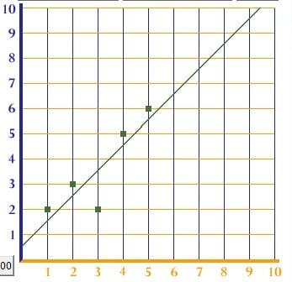

**2016:**

**Calculations:**

∑x= 31878 ∑y= 14178.56 ∑x^2= 5366130 ∑y^2= 801158.8

∑xy= 1736944 n = 252

m = 252(1736944) - (31878)(14178.56)

252(5366130) - (31878)^2

m = 437709888 – 451984135.68

1352864760 – 1016201884

m = -0.0425

b = 14178.56 – (-0.0425)( 31878)

252

b = 14178.56 + 1334.82

252

b = 61.6

y = -0.0425x + 61.6

**2017:**

**Calculations:**

∑x= 31626 ∑y= 13961.12 ∑x^2= 5302626 ∑y^2= 779004.7

∑xy=1778778 n = 251

m = 251(1778778) - (31626)(13961.12)

251(5302626) - (31626)^2

m = 446473278 – 441534381.12

1330959126 – 1000203876

m = 0.0149

b = 13961.12 – (0.0149)(31626)

251

b = 13961.12 - 471.23

251

b = 53.74

y = 0.0149x + 53.74

**2018:**

**Calculations:**

∑x= 31626 ∑y= 18313.02 ∑x^2= 5302626 ∑y^2= 1345183

∑xy= 2384628 n = 251

m = 251(2384628) - (31626)(18313.02)

251(5302626) - (31626)^2

m = 598541628 – 579167570.52

1330959126 – 1000203876

m = 0.0586

b = 18313.02– (0.0586)(31626)

251

b = 18313.02 – 1853.284

251

b = 65.58

y = 0.0586x + 65.58

**2019:**

**Calculations:**

∑x= 31878 ∑y= 21850.58 ∑x^2=5366130 ∑y^2= 1902730

∑xy= 2844345 n = 252

m = 252(2844345) - (31878)( 21850.58)

252(5366130) - (31878) ^2

m = 716774940 – 696552789.24

1352264760 – 1016206884

m = 0.0602

b = 21850.58– (0.0602)( 31878)

252

b = 21850.58– 1919.0556

252

b = 79.097

y = 0.0602x + 79.097

**2020:**

**Calculations:**

∑x= 32131 ∑y= 26930.23 ∑x^2= 5430139 ∑y^2= 2954890

∑xy= 3702946 n = 253

m = 253(3702946) - (32131)( 26930.23)

253(5430139) - (32131)^2

m = 936845338 – 865295220.13

1373825167 – 1032401161

m = 0.2096

b = 26930.23– (0.2096)( 32131)

253

b = 26930.23– 6734.6576

253

b = 79.829

y = 0.2096x + 79.829

**2016-2020:**

**Calculations:**

∑x= 793170 ∑y= 95233.51001 ∑x^2=665998410 ∑y^2= 7782967.32

∑xy=68744440.74 n = 1259

m = 1259(68744440.74) - (793170)( 95233.51001)

1259(665998410) - (793170)^2

m = 86549250891.66 – 75536363134.6317

838491998140 – 629118648900

m = 0.052599

b = 95233.51001– (0.052599)(793170)

1259

b = 95233.51001– 41719.94883

1259

b = 42.5048

y = 0.052599x + 42.5048

**Analysis (2016-2020):**

The slope of line of best fit indicates the trend of the data being studied. I studied Nike’s stock price over the 5-year period 2016-2020. I noted that the slope is positive which indicates that the stock price has been increasing, but at slow rate of 0.052599. If this was the sole data on which an investment decision must be made, it will result in a decision to invest in this stock.

In 2016, the slope was negative which indicated that the stock price had been decreasing, but at a slow rate of -0.0425. This price decrease may have been impacted by the kneeling of an athlete during the national anthem. Since it was to protest police brutality against black people, Nike recorded a lose of around 4 billion dollars.

In 2017, the slope was positive which indicated that the stock price had been increasing, but at a slow rate of 0.0149. This increasing was after the fact that a Nike athlete took a knee during the national anthem. Nike stock prices started to go back up though very slowly.

In 2018, the slope was positive which indicated that the stock price had been increasing, but at a slow rate of 0.0586. 2018 was another positive year for Nike’s stock where their stock value kept increasing.

In 2019, the slope was positive which indicated that the stock price had been increasing, but at a slow rate of 0.0602. 2019 was not the best year for Nike because we can see that from 2017 to 2018 the stock value went up by 0.0437. From 2018 to 2019 it only went up by 0.0016. This was a slow year for Nike.

In 2020, the slope was positive which indicated that the stock price continued increasing, but at its highest rate of 0.2096. Nike’s stock increased by 2.0358 which is a lot. Even though covid-19 hit, Nike was able to sell online fast. Nike is one of the stocks that did not crumble during the pandemic.

**Linear Regression and Extrapolation:**

Linear regression tries to show the relationship between two variables by applying a linear equation to observed data. It is a process by which the line of best fit is mathematically determined. Extrapolation is the process to predict values that fall outside a range of data points that are known. We will be extrapolating to determine the estimated value of Nike’s stock one month, six months, one year, and ten years after our given data. For each of these we will need to determine what day value is related to the certain point in time. After the day is found (x) we can then input this value into our line of best fit formula to get the estimated stock price.

**One Month:**

252/12 = 21 1259 + 21 = 1280

y = 0.052599x + 42.5048 y = 0.052599(1280) + 42.5048 y = 109.83152

Therefore, in one month Nike’s stock value is estimated to be 109.83152$

**Six Months:**

252/2 = 126 1259 + 126 = 1385

y = 0.052599x + 42.5048 y = 0.052599(1385) + 42.5048 y = 115.354415

Therefore, in six months Nike’s stock value is estimated to be 115.35442$

**One Year :**

252/1 1259 + 252 = 1511

y = 0.052599x + 42.5048y = 0.052599(1511) + 42.5048 y = 121.98182

Therefore, in one year Nike’s stock value is estimated to be 121.98182$

**Ten Years:**

We must multiply the past period of five years (1259) by three.

1259 x 3 = 3777

y = 0.052599x + 42.5048 y = 0.052599(3777) + 42.5048 y = 241.171

Therefore, in ten years Nike’s stock value is estimated to be 241.171$

**Standard Deviation:** σ = √ ∑(x−μ )^2

N

The standard deviation of a data set is the average difference between each data point and the mean value. In relation to stocks this piece of information illustrates how much a stock fluctuates on average from the mean. If the number is large, we can tell that the line of best fit may not be a good indication of how that stock does over time or that a stock may be unreliable. In Excel, I used the formula “=stdevp” to calculate the standard deviation

**2016** : σ = √ ∑(x−μ )^2 = √ 3414.540405 = 3.681

N 252

Therefore, in 2016 the standard deviation was 3.681

**2017** : σ = √ ∑(x−μ )^2 = √ 2459.389 = 3.130234

N 251

Therefore, in 2017 the standard deviation was 3.130234

**2018** : σ = √ ∑(x−μ )^2 = √ 9060.969 = 6.008284

N 251

Therefore, in 2018 the standard deviation was 6.008284

**2019** : σ = √ ∑(x−μ )^2 = √ 8096.073 = 5.668093

N 252

Therefore, in 2019 the standard deviation was 5.668093

**2020** : σ = √ ∑(x−μ )^2 = √ 88339.57 = 18.68604

N 253

Therefore, in 2020 the standard deviation was 18.68604

**2016-2020:** σ = √ ∑(x−μ )^2 = √ 579296.6065 = 21.45051024

N 1259

Therefore, in the past five years the standard deviation was 21.45051024

**Correlation Coefficient :**

The correlation coefficient is a measure of how well a linear model fits a two-variable set of data. It gives a quantitative measure of how closely the data points cluster around the line of best fit. For a positive correlation, the values range from 0 to 1 where 1 is a perfect positive correlation. For a negative correlation, the values can range from 0 to -1 where -1 is a perfect negative correlation. Correlations between -1 and 1 would be strong, moderate or weak. In excel I used “=CORREL”

r = 𝑛Σ𝑥𝑦−Σ𝑥Σ𝑦

√𝑛Σ𝑥^2−(Σ𝑥)^2 √𝑛Σ𝑦^2−(Σy)^2

**2016 :**

252(1736944)−(31878)(14178.56)

√252(5366130)−( 31878)^2 √252(801158.8)−(14178.56)^2

r = -0.84 - Very strong negative correlation

**2017 :**

251(1778778)−(31626)(13961.12)

√251(5302626)−(31626)^2 √251(779004.7)−(13961.12)^2

r = 0.3456 - Moderate positive correlation

**2018 :**

251(2384628)−(31626)(18313.02)

√251(5302626)−(31626)^2 √251(1345183)−(18313.02)^2

r = 0.7064 - Strong positive correlation

**2019 :**

252(2844345)−(31878)(21850.58)

√252(5366130)−(31878)^2 √252(1902730)−(21850.58)^2

r = 0.7723 - Strong positive correlation

**2020 :**

252(1736944)−(31878)(14178.56)

√252(5366130)−( 31878)^2 √252(801158.8)−(14178.56)^2

r = 0.8191 - Very strong positive correlation

**2016-2020:**

1259(68744440.74)−(793170)(95233.51001)

√1259(665998410)−(793170)^2 √1259(7782967.32)−( 95233.51001)^2

r = 0.8912 - Very strong positive correlation

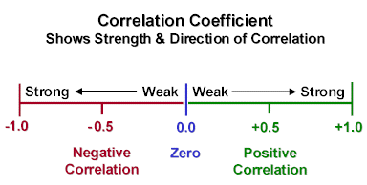

**Measures of Central Tendency:**

Mean: The mean represents the average of one variable in a data set. The mean is simply the sum of all the values of one variable divided by the amount of that variable. For our data we will find the mean of the “y” value or the opening price of the stock as finding the average of the number of days would not be of use to us.

Median: The median is the middle number, or the average of the two middle numbers of a set of data once the data has been arranged from least to greatest value. To find which data point will be used for the median the number of terms is taken and is divide by two to find which term is the middle term. If the answer is a decimal 0.5 the number should be rounded up to find the term that will be used. If the answer is round, then you must find the average of that term and the term after it to find the true median.

Mode: The mode of a data set is the value which occurs the most often. There is no mathematical formula for mode except for counting out how many of each value exist.

**2016:**

Mean: μ = ∑ y = 14178.56 = 56.26413

N 252

Median: Mt = N 252 = 126 = 56.465

2 2

Mode: 55, by doing =MODE(E:E)

**2017:**

Mean: μ = ∑ y = 13961.12 = 55.621992

N 251

Median: Mt = N 251 = 126 = 55.12

2 2

Mode: 53.02, by doing =MODE(E:E)

**2018:**

Mean: μ = ∑ y = 18313 = 72.96024

N 251

Median: Mt = N 251 = 126 = 73.1

2 2

Mode: 68.39, by doing =MODE(E:E)

**2019:**

Mean: μ = ∑ y = 21850.58 = 86.70865

N 252

Median: Mt = N 252 = 126 = 85.84

2 2

Mode: 84.9, by doing =MODE(E:E)

**2020:**

Mean: μ = ∑ y = 26930.23 = 106.4436

N 253

Median: Mt = N 251 = 126 = 101.31

2 2

Mode: 101, by doing =MODE(E:E)

**2016-2020:**

Mean: μ = ∑ y = 95233.51001 = 75.64218

N 1259

Median: Mt = N 1259 = 630 = 72.339996

2 2

Mode: 55, by doing =MODE(C:C)

**Reflection/Mathematical Understanding of Material:**

I was not informed of Nike as a publicly traded organization. I knew that they created clothing and sport gear. I knew nothing about any huge occasions at the organization throughout the most recent 5 years. I began seeing Nike’s stock when the CPT was relegated. While I performed different numerical computations on the stock value information and afterward researched explanations behind certain trends, I got familiar with the organization and occasions that occurred within the 5-year span.

I discovered the line of best fit for the 5-year time frame (2016-2020), utilizing the linear regression formula. I understood that to compare the information, I had to do a line of best fit for every one of the years independently. This provided me with a superior comprehension of periods when the slant went up or down (positive/negative) and at what rate(fast/slow). This enhanced my insight into the organization and a few key occasions that occurred in the 5-year time frame which most likely affected the developments of the cost of one share.

I noticed that the line of best fit plots a pattern line. When I evaluated the scatter plots, a few years showed steep changes, and these would reflect times of more noteworthy unpredictability (Covid-19). This typically happens when there is an occasion that impacts the stock cost.

I figured out how to involve extrapolation through the linear regression formula to predict costs for future dates. In any case, there are different things that could influence a future stock cost making the linear regression formula not as precise as it should be.

The mean, median and mode was helpful because it changed my insight into how these could be utilized in understanding trends. While working out the mean of every year, I got a comprehension of the normal cost for every year and for the 5-year time frame. Looking at the method for every period provided me with a comprehension of whether the cost was going up or down. I understood the trends of the stock costs in every period when I discovered the medians. When I recognized the mode for every one of the periods, I got a sign of the most well-known value event in every one of the periods.

Looking at the standard deviations for the 5-year time frame, every year exclusively assisted me with understanding that information could be spread close or a long way from the mean. I learnt the effect that standard deviations could have on the exactness of the line of best fit.

Then I had to determine the correlation coefficients for every year. Thus, positive, or negative, a correlation coefficient of 1 or - 1 is strong. I improved how I interpret the connection between the variable and the line of best fit. I discovered that the nearer the information focuses are to the line of best fit, the more exact the line becomes for making linear regression formula assessments.

For the box and whisker plots, I simply watched a YouTube video and understood how to do it in excel. Thus, enhancing my excel knowledge and research skills. The plot showed a visual representation of quartiles, median, greatest, and least variables. This was valuable in understanding the spread of stock costs over the periods. The size of each box recognizes which quartile of information happens most frequently in every period. Graphing these plots makes it more straightforward to understand. Though, I did not find it hard to plot on excel because I had some excel knowledge prior to this course.

**Box and Whisker Plots:**

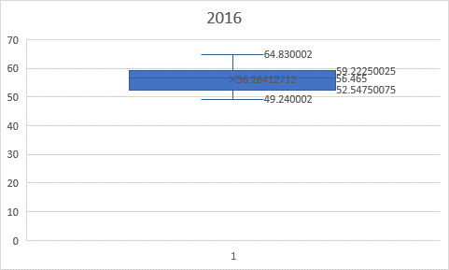

Max: 64.83 Min: 49.24 Median: 56.465

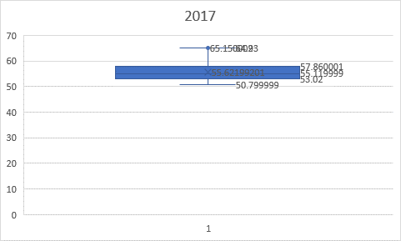

Max: 65.15 Min: 50.799 Median: 55.11999

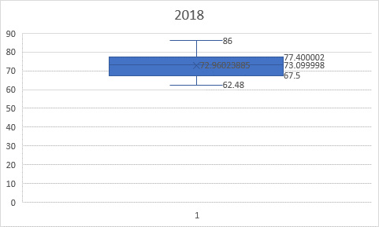

Max: 86 Min: 62.48 Median: 73.0999

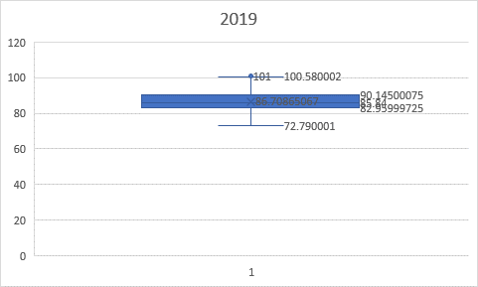

Max: 101 Min: 72.79 Median: 85.84

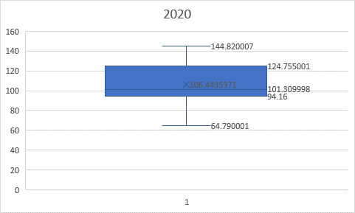

Max: 144.82 Min: 64.79 Median: 101.30999

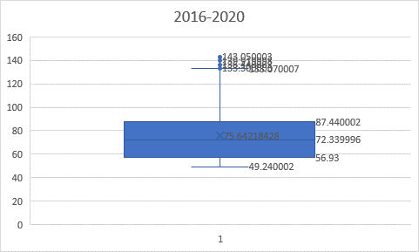

Max: 144.82 Min: 49.24 Median: 72.33999

**Bibliography:**

<https://investors.nike.com/Home/default.aspx>

<https://www.nytimes.com/2018/09/26/sports/nike-colin-kaepernick.html>

<https://www.macrotrends.net/stocks/charts/NKE/nike/stock-price-history>

<https://www.investopedia.com/articles/economics/09/subprime-market-2008.asp>

<https://www.nasdaq.com/articles/nike-swings-to-quarterly-loss-on-covid-19-impact-shares-fall-2020-06-25>

<https://www.cnn.com/2021/09/24/business/nike-stock-earnings-supply-chains-intl-hnk/index.html>

<https://www.nike.com/ca/help/a/nikeinc-mission>

<https://finance.yahoo.com/quote/NKE/>

<https://www.cnbc.com/quotes/NKE>